### Probability of an Outcome Given a Hidden Path Problem

*Compute the probability that an HMM will emit a string given its hidden path.*

**Input:** A string *x* emitted by an HMM (*Σ*, *States*, *Transition*, *Emission*) and a hidden path *π*.

**Output:** The conditional probability Pr(*x*|*π*) that *x* will be emitted given that the HMM follows the hidden path *π*.

**Input Format.** The first line of the input contains the outcome string *x*. The second line of the input is “--------” (a delimiter). The third line of the input is the list of symbols in the alphabet *Σ* (space-separated). The fourth line of the input is “--------” (a delimiter). The fifth line of the input contains the hidden path *π*. The sixth line of the input is “--------” (a delimiter). The seventh line of the input is the list of states *States* (space-separated). The eighth line of the input is “--------” (a delimiter). The remaining lines are the emission matrix *Emission*, depicted as a tab-delimited |*States*| by |*Σ*| matrix as shown in the sample dataset. You may assume that transitions from the initial state occur with equal probability.

**Output Format.** The conditional probability Pr(*x*|*π*) that *x* will be emitted given that the HMM follows the hidden path *π.* Your answer should be accurate up to at least 3 significant figures. For example, if the answer is 0.00**123**4678 (three significant figures are shown in bold) then even an imprecise answer like 0.00123 will be accepted by the grader because it is within 0.00**001** from the correct solution.

**Constraints.** |*x*| = |*π*| = 50; |*States*| = 2; |*Σ*| = 3

**SAMPLE DATASET:**

Input:

zzzyx

--------

x y z

--------

BAAAA

--------

A B

--------

x y z

A 0.176 0.596 0.228

B 0.225 0.572 0.203

Output:

0.001106941474

We are given the hidden path BAAAA. The series of events to generate the string zzzyx given this hidden path and HMM is the following:

* Emit z while in state B (0.203)
* Emit z while in state A (0.228)
* Emit z while in state A (0.228)
* Emit y while in state A (0.596)
* Emit x while in state A (0.176)

Thus, the probability of generating the string zzzyx given the hidden path BAAAA in this HMM is 0.203*0.228*0.228*0.596*0.176=0.001106941474.

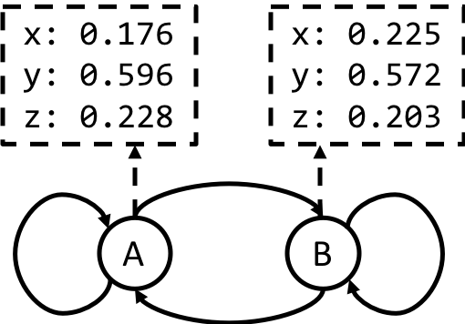

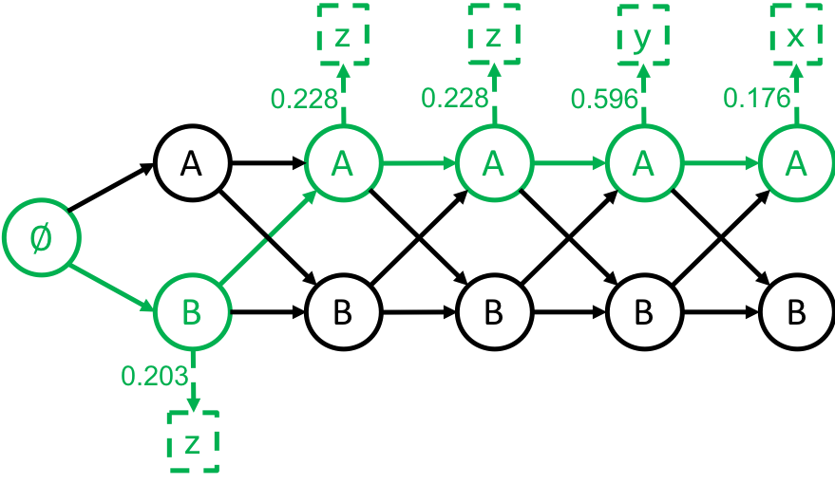

**TEST DATASET 1:**

Input:

x

--------

x

--------

A

--------

A B

--------

x

A 1

B 1

Output:

1.0

This dataset makes sure that your code is not considering the starting state when calculating the probability of the outcome. While the starting state does have transition probabilities, it does not have any emission probabilities associated with it. If your output doesn’t match the correct output make sure that your code doesn’t try to apply a transition probability from the initial state.

**TEST DATASET 2:**

Input:

xx

--------

x y

--------

AB

--------

A B

--------

x y

A 0.6 0.4

B 0.3 0.7

Output:

0.18

This dataset makes sure that your code is correctly parsing and applying the emission matrix. More specifically this dataset tests that your implementation uses the correct emission probability for each state. If your output doesn’t match the correct output make sure that your code uses the correct emission probabilities. In this case it should consider the probability of state A emitting character x (0.6) and state B emitting character x (0.3). The final result then becomes 0.6*0.3=0.18.

**TEST DATASET 3:**

Input:

xy

--------

x y

--------

AA

--------

A B

--------

x y

A 0.6 0.4

B 0.3 0.7

Output:

0.24

This dataset makes sure that your code is correctly parsing and applying the emission matrix. More specifically this dataset makes sure that your code uses the correct emission probability for different characters emitted by the same state. If your output doesn’t match the correct output make sure that your code is using the correct emission probabilities. In this case it should consider the probability of state A emitting character x (0.6) and state A emitting character y (0.4). The final result then becomes 06*0.4=0.24.

**TEST DATASET 4:**

Input:

xxxxxyxyyx

--------

x y

--------

AABBABABBA

--------

A B

--------

x y

A 0.01 0.99

B 0.01 0.99

Output:

9.70e-15

This dataset checks to make sure your output is to at least three significant figures. This is not the same as three digits past the decimal point. If your output is incorrect make sure that your code doesn’t round the final answer to three digits past the decimal point. Scientific notation using a lowercase e (as in the example output) is accepted. Do not output scientific notation in the style of 9.70*10-15 or 9.70x10-15.